Python Data Types

In python programming, data type is an important concept.
Every programming language defines variables that hold specific kinds of information, and Python is no exception. The specific kind of variable is called a data type. Knowing the data type of a variable is important because it tells you what kind of information you find inside. In addition, when you want to store information in a variable, you need a variable of the correct data type to do it. Python doesn’t allow you to store text in a variable designed to hold numeric information. Doing so would damage the text and cause problems with the application. You can generally classify Python data types as numeric, string, and Boolean, although there really isn’t any limit on just how you can view them. The following sections describe each of the standard Python data types within these classifications.
To place a value into any variable, you make an assignment using the assignment operator (=)
Python has the following data types built-in by default, in these categories:
Text Type: | Str
Numeric Types: | int, float, complex
Sequence Types: | list, tuple, range
Mapping Type: | Dict
Set Types: | set, frozenset
Boolean Type: | Bool
Binary Types: | bytes, bytearray, memoryview

Python Numbers
There are three numeric types in Python:
- int
- float
- complex
Variables of numeric types are created when you assign a value to them:

Example
x = 1 # int
y = 2.8 # float
z = 1j # complex
Integers Any whole number is an integer. For example, the value 1 is a whole number, so it’s an integer. On the other hand, 1.0 isn’t a whole number; it has a decimal part to it, so it’s not an integer. Integers are represented by the int data type.
Float Any number that includes a decimal portion is a floating-point value. For example, 1.0 has a decimal part, so it’s a floating-point value. Many people get confused about whole numbers and floating-point numbers, but the difference is easy to remember. If you see a decimal in the number, then it’s a floatingpoint value. Python stores floating-point values in the float data type.
Complex A complex number consists of a real number and an imaginary number that are paired together.

To verify the type of any object in Python, use the type() function:
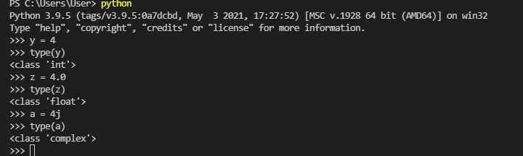

How to Specify a Variable Type
There may be times when you want to specify a type on to a variable. This can be done with casting.
Casting in python is therefore done using constructor functions:
- int() - constructs an integer number from an integer literal, a float literal (by rounding down to the previous whole number), or a string literal (providing the string represents a whole number)
- float() - constructs a float number from an integer literal, a float literal or a string literal (providing the string represents a float or an integer)
- str() - constructs a string from a wide variety of data types, including strings, integer literals and float literals
EXAMPLE:
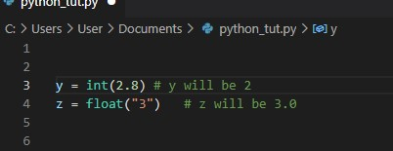

Python Strings
Strings in python are surrounded by either single quotation marks, or double quotation marks.
A string is simply any grouping of characters you place within double quotes or single quotes.
Strings are a data type in Python for dealing with text.
Creating a string
A string is created by enclosing text in quotes. You can use either single quotes, ', or double quotes, ". A triple-quote can be used for multi-line strings. Here are some examples:
s = 'Hello'
t = "Hello"
7m = """This is a long string that
is spread across two lines."""
You can display a string literal with the print() function:
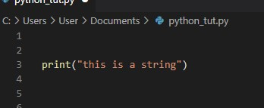
Empty string The empty string “” is the string equivalent of the number 0. It is a string with nothing in it.
To get the length of a string (how many characters it has), use the built-in function len(). For example, len('Hello') is 5.

Concatenation and Repetition
The operators + and * can be used on strings. The + operator combines two strings. This operation is called concatenation. The * repeats a string a certain number of times. Here are some examples.
Input | result
'AB'+'cd' | ABcd
'A'+'7'+'B' | A7B
'Hi'*4 | HiHiHiHi

TIP: If we want to print a long row of dashes, we can do the following print('-'*75)

The in operator
The in operator is used to tell if a string contains something. For example:
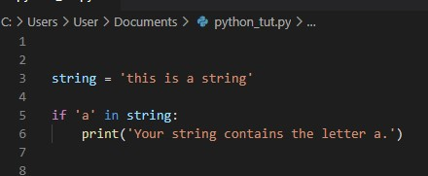

You can combine in with the not operator to tell if a string does not contain something:
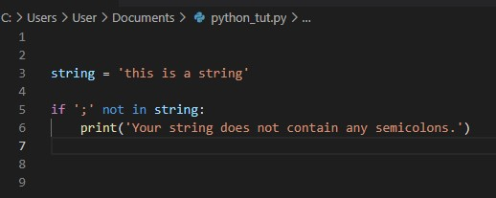
NOTE: we will learn about conditions; “if” soon just understand the concept of “in” and “not in”

Assign String to a Variable
Assigning a string to a variable is done with the variable name followed by an equal sign and the string:

Example
a = "Hello"
You can use either single quotes or double quotes. A triple-quote can be used for multi-line strings. Here are some examples:
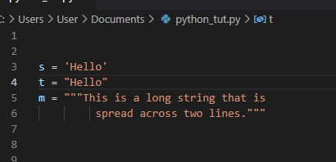

Note: in the result, the line breaks at the same points in the code

Strings are Arrays
Like many other popular programming languages, strings in Python are arrays of bytes representing unicode characters.
However, Python does not have a character data type, a single character is simply a string with a length of 1.
Square brackets can be used to access elements of the string.
We will often want to pick out individual characters from a string. Python uses square brackets to do this. The table below gives some examples of indexing the string s='Python'.
statement | result | Description
s[0] | P | first character of s
s[1] | y | second character of s
s[-1] | n | last character of s
s[-2] | o | second-to-last character of s

Slicing
You can return a range of characters by using the slice syntax.
A slice is used to pick out part of a string. It behaves like a combination of indexing and the range function. Below we have some examples with the string s='abcdefghij'.
index: 0 1 2 3 4 5 6 7 8 9
letters: a b c d e f g h i j
Code | result | Explanation
s[2:5] | cde | characters at indices 2, 3, 4
s[ :5] | abcde | first five characters
s[5: ] | fghij | characters from index 5 to the end
s[-2:] | ij | last two characters
s[ : ] | abcdefghij | entire string
s[1:7:2] | bdf | characters from index 1 to 6, by twos

The basic structure is string name[starting location : endinglocation+1]

Negative Indexing
Use negative indexes to start the slice from the end of the string:

Example
Get the characters from position 5 to position 1, starting the count from the end of the string:
b = "Hello, World!"
print(b[-5:-2])

String methods
Strings come with a ton of methods, functions that return information about the string or return a new string that is a modified version of the original. Here are some of the most useful ones:
method | description
lower() | returns a string with every letter of the original in lowercase
upper() | returns a string with every letter of the original in uppercase
replace(x,y) | returns a string with every occurrence of x replaced by y
count(x) | counts the number of occurrences of x in the string
index(x) | returns the location of the first occurrence of x
isalpha() | returns True if every character of the string is a letter
Tip: To see a list of all the string methods, type dir(str) into the Python shell
Tip: The values “True” and “False” are called booleans and are covered

Escape Character
To insert characters that are illegal in a string, use an escape character.
An escape character is a backslash \ followed by the character you want to insert.
An example of an illegal character is a double quote inside a string that is surrounded by double quotes
There are a variety of escape characters, and here are the most useful ones:
character | description
\n | The new line character is used to move to the next line
\' | This is for inserting apostrophes into strings
\\ | This is used to get the backslash itself. For example:  filename = 'c:\\programs\\file.py'
\xhh | Hex value
\b | Backspace
\ooo | Octal value

Boolean Values
In programming you often need to know if an expression is True or False.
You can evaluate any expression in Python, and get one of two answers, True or False.
Booleans can help make your programs more readable. They are often used to indicate options. Booleans are often used as conditions in if statements and while loops and you can even assign them to variables.
Example:
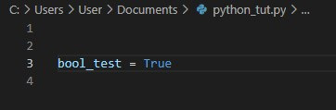
We have seen booleans before. The isalpha string method returns True if every character of the string is a letter and False otherwise.
When you compare two values, the expression is evaluated and Python returns the Boolean answer
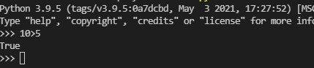
When you run a condition in an if statement, Python returns True or False:
In the example below we can print a message depending on if the condition that the variable num2 greater than the variable num1, if it is true or false the program will print a string:
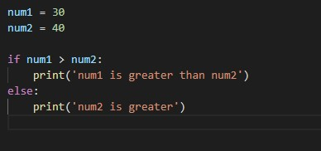

Most Values are True
Almost any value is evaluated to True if it has some sort of content.
Any string is True, except empty strings.
Any number is True, except 0.
Any list, tuple, set, and dictionary are True, except empty ones.
EXAMPLE:
The following examples will output true
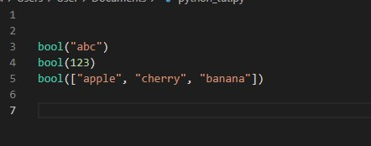

Some Values are False
There are not many values that evaluates to False, except empty values, like (), [], {}, "", the number 0, and the value None. The value False evaluates to False.
Example:
The following lines of code will return “false”
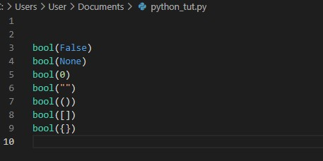

Python Collections (Arrays)
There are four collection data types in the Python programming language:
- List is a collection which is ordered and changeable. Allows duplicate members.
- Tuple is a collection which is ordered and unchangeable. Allows duplicate members.
- Set is a collection which is unordered and unindexed. No duplicate members.
- Dictionary is a collection which is unordered, changeable and indexed. No duplicate members.
When choosing a collection type, it is useful to understand the properties of that type. Choosing the right type for a particular data set could mean retention of meaning, and, it could mean an increase in efficiency or security.

Lists
A list is a collection which is ordered and changeable. In Python lists are written with square brackets.
Say we need to get thirty test scores from a user and do something with them, like put them in order. We could create thirty variables, score1, score2, ..., score30, but that would be very tedious. To then put the scores in order would be extremely difficult. The solution is to use lists.
Creating lists Here is a simple list:

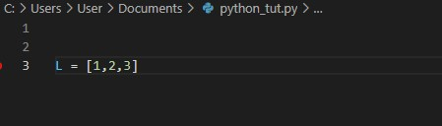
We use square brackets to indicate the start and end of the list, and separate the items by commas.
The empty list
The empty list is []. It is the list equivalent of 0 or '' or False.
Long lists
If you have a long list to enter, you can split it across several lines, like below:
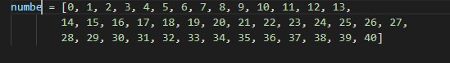
Printing lists
You can use the print function to print the entire contents of a list.
EXAMPLE:
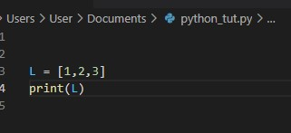
Output:
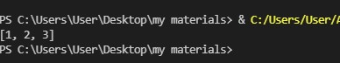
You access items from a list by referring to its index number.
EXAMPLES:
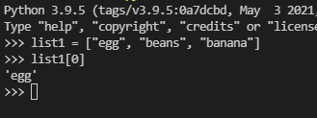
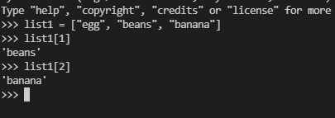

Negative Indexing
Negative indexing means beginning from the end, -1 refers to the last item, -2 refers to the second last item.
EXAMPLE:
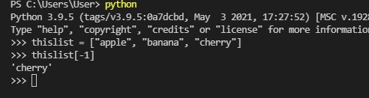

Lists can contain all kinds of things, even other lists. For example, the following is still a valid list:
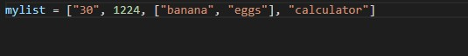

Range of Indexes
You can specify a range of indexes by specifying where to start and where to end the range.
When specifying a range, the return value will be a new list with the specified items.
EXAMPLE:
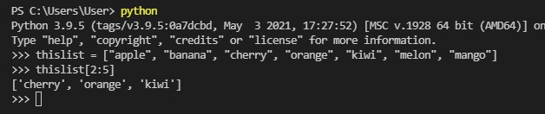
NOTE: the last index is not included, to get “melon” to be included the second index has to look like this: thislist = [2:6]

Loop Through a List
You can loop through a list by using a “for” loop just like this:
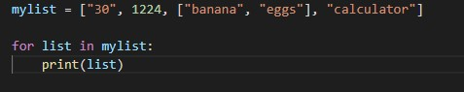
Note: we would be talking about loops very soon.

Check if Item Exists
To check if a specified item is present in a list use the in keyword:
EXAMPLE:
To check if “apple” is in the list “thislist”
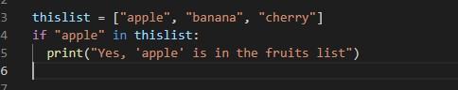
Note: we would also learn about “if” conditions very soon.

To know how many items a list has, use the len() function:
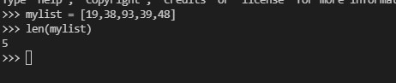

To add an item to the end of the list, use the append() method:
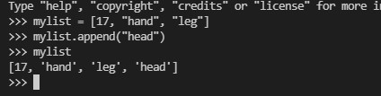

To add an item at the specified index, use the insert() method where the index position of the item to be added will be the first argument, followed by the item to be added. ENAMPLE:
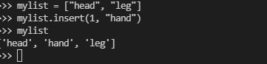

Remove Item from a list
There are different methods to remove/delete items from a list:
- The remove() method removes the specific item you want.
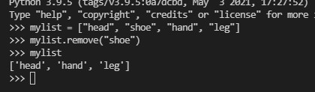
- The pop method removes a specified index; the default position is the last item on the list.
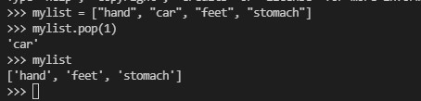
- The del keyword removes the specified index and can also delete the entire list
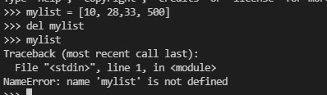
- The clear() method empties the list. (NOT DELETE)
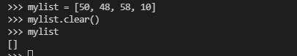

How to Copy a List
You cannot copy a list simply by typing list2 = list1, because: list2 will only be a reference to list1, and changes made in list1 will automatically also be made in list2.
There are ways to make a copy, one way is to use the built-in List method copy().
The python copy method creates a copy of an existing list. The copy method is added to the end of any list object and so it does not accept any parameters. Copy returns a new list. Python includes a built in function to support creating a shallow copy of a list.
We can use an equal sign to copy a list “A” but any change made to the list “A” will also be made in the copy.
EXAMPLE:
Making copy of a list using the copy method
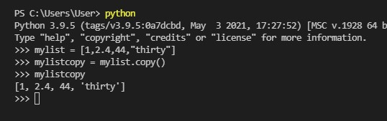

SPLIT
The split method returns a list of the words of a string. The method assumes that words are separated by whitespace, which can be either spaces, tabs or newline characters. Here is an example:
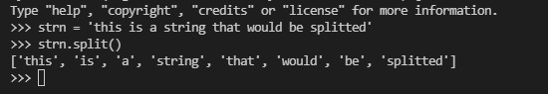

JOIN
The join method is in some sense the opposite of split. It is a string method that takes a list of strings and joins them together into a single string. Here is an example:
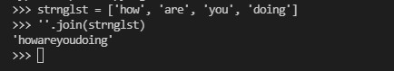

HOW TO JOIN A LIST
There are several ways to join, or concatenate, two or more lists in Python.
One of the easiest ways is by using the “+” operator.
EXAMPLE:
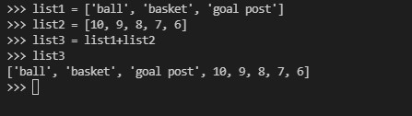
Or you can use the extend method, which purpose is to add elements from one list to another list:
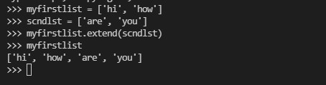

It is also possible to use the list() constructor to make a new list.
EXAMPLE:
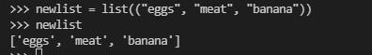

List of some python list methods
method | description
Count() | Return the number of occurrences of a value
clear() | Removes all items from a list
sort() | Sorts the list
insert() | Adds an item at a desired position
pop() | Removes an item at a desired position
append() | Adds an item at the end of the list
Index() | Returns the index of a particular value/item

Tuple
A tuple is a collection which is ordered and unchangeable. In Python tuples are written with round brackets. A tuple is essentially an immutable list.
A tuple is a collection used to create complex list-like sequences. An advantage of tuples is that you can nest the content of a tuple.
One reason why there are both lists and tuples is that in some situations, you might want an immutable type of list. For instance, lists cannot serve as keys in dictionaries because the values of lists can change and it would be a nightmare for Python dictionaries to have to keep track of. Tuples, however, can serve as keys in dictionaries.
An empty tuple is ()
Example of a tuple:
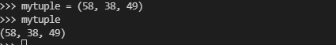
To access a tuple we use refer to the index of the item inside square brackets, just like a list.

Negative Indexing
Negative indexing means beginning from the end, -1 refers to the last item, -2 refers to the second last item etc. just like lists, tuples can be indexed negatively.
Example:
To get the last item of a tuple
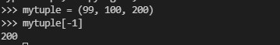

You can also specify a range of indexes by specifying where to start and where to end the range.
When specifying a range, the return value will be a new tuple with the specified items.
Example:
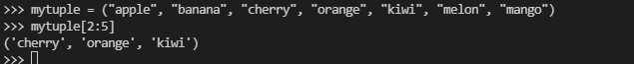
Note that the results start at the index 2 and ends at the index 5 ie the last index is not included

Negative indexing
Specify negative indexes if you want to start the search from the end of the tuple, it works just like a list
Example:
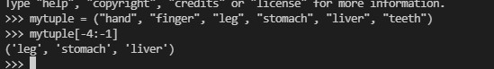
Also note that the last index range which is “teeth” or -1 is excluded from the result.

Changing the value of a tuple
Once a tuple is created, you cannot change its values. Tuples are unchangeable, or immutable as it also is called. A tuple is essentially an immutable list
But you can convert the tuple into a list, change the list, and convert the list back into a tuple.
Example:
Here we convert a tuple to a list to be able to change the value “biscuit” to “milk” and then turn it back into a tuple.
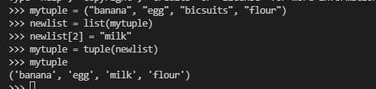

How to loop through a tuple
You can loop/iterate through the tuple items by using a for loop.
Example:
Here we loop through a tuple and print all the values.
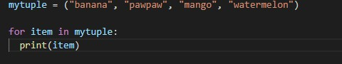
Note: we would be learning about loops in the next stage.

How to check if an item is in a tuple
To know if a desired item is present in a tuple use the “in” keyword.
Example:
Here we check if the item “mango” is in the tuple
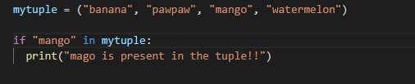

Tuple Length
To determine the number of items in a tuple, use the len() method:
Example:
To determine the length of the tuple “mytuple”
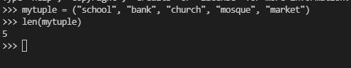

Adding Items to a tuple
Once a tuple is created, you cannot add items to it. Tuples are unchangeable.

How to Create Tuple with One item
To create a tuple with only one item, you have to add a comma after the item, unless Python will not recognize the variable as a tuple.
Example:
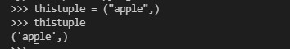
Example of a wrong single tuple and a correct single tuple:
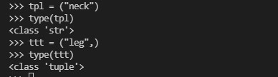

Remove Items
Note: You cannot remove items in a tuple.
Tuples are unchangeable, so you cannot remove items from it, but you can delete the tuple completely:

Example
The del keyword can delete the tuple completely:

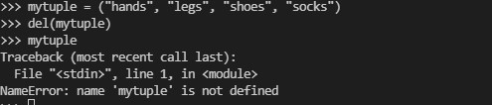

How to Join Two Tuples
To join two or more tuples, you can use the + operator:

Example
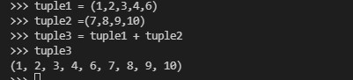

tuple() Constructor
you can also make a tuple using the tuple() constructor, just like a list.

Example
Using the tuple() method to make a tuple:
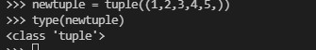

Tuple Methods
Python has two built-in methods that you can use on tuples.
method | description
Count() | Returns the number of times a value occurs in a tuple
Index() | Searches the tuple for a value and returns the index position

Test Yourself With Exercises

Python Sets

A set is a collection which is unordered and unindexed. In Python sets are written with curly brackets.
They are a lot like lists with no repeats. Sets are denoted by curly braces, like below:
Example:
To create a set
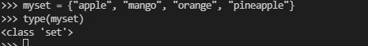
Note: Sets are unordered, so you cannot be sure in which order the items will appear.
Recall that curly braces are also used to denote dictionaries, and {} is the empty dictionary. To get the empty set, use the set function with no arguments, like this:
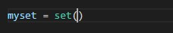
This set function can also be used to convert things to sets. Example:
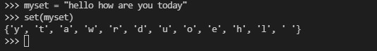
Notice that Python will store the data in a set in whatever order it wants to, not necessarily the order you specify. It’s the data in the set that matters, not the order of the data. This means that indexing has no meaning for sets. You can’t do myset[0], for instance.
Take note once again that a set does not repeat any item so all characters present on the string “hello how are you today” are in the set.
We can use the fact that a set can have no repeats to remove all repeats from a list. Here is an example:
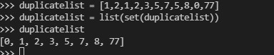

Accessing Items in a set
You cannot access items in a set by referring to an index, since sets are unordered the items has no index.
But you can loop through the set items using a for loop, or ask if a specified value is present in a set, by using thein keyword.

Example
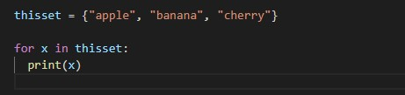

Example
Check if "banana" is present in the set:

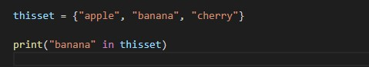

Changing Items in a set
Once a set is created, it is not possible to change the items in it, but you can add new items.

Add Items
To add one item to a set use the add() method.
To add more than one item to a set use the update() method.

Example
Add an item to a set, using the add() method:
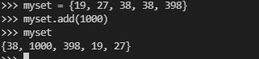

Example
Add multiple items to a set, using the update() method:
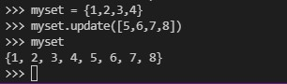

Get the Length of a Set
To determine how many items a set has, use the len() method.

Remove Item
To remove an item in a set, use the remove(), or the discard() method.
Example
Remove eggs from the set
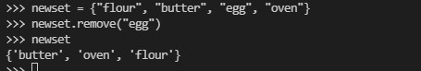
Note: If the item being removed does not exist, remove() will raise an error.

Example
Remove egg from the set using the discard() method
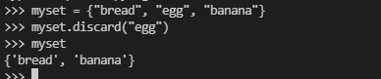
Note that if the item being removed with the discard() method does not exist discard() will not raise an error.
You can also use the pop(), method to remove an item, but this method will remove the last item. Remember that sets are unordered, so you will not know what item that gets removed.
The return value of the pop() method is the removed item.

Example
Remove the last item by using the pop() method:
thisset = {"apple", "banana", "cherry"}
x = thisset.pop()
print(x)
print(thisset)
Note: Sets are unordered, so when using the pop() method, you will not know which item that gets removed.

Example
The clear() method empties the set:
thisset = {"apple", "banana", "cherry"}
thisset.clear()
print(thisset)

Example
The del keyword will delete the set completely:
thisset = {"apple", "banana", "cherry"}
del thisset
print(thisset)

Join Two Sets
There are several ways to join two or more sets in Python.
You can use the union() method that returns a new set containing all items from both sets, or the update()method that inserts all the items from one set into another:

Example
The union() method returns a new set with all items from both sets:
set1 = {"a", "b" , "c"}
set2 = {1, 2, 3}
set3 = set1.union(set2)
print(set3)

Example
The update() method inserts the items in set2 into set1:
set1 = {"a", "b" , "c"}
set2 = {1, 2, 3}
set1.update(set2)
print(set1)
Note: Both union() and update() will exclude any duplicate items.
There are other methods that joins two sets and keeps ONLY the duplicates, or NEVER the duplicates, check the full list of set methods in the bottom of this page.

The set() Constructor
It is also possible to use the set() constructor to make a set.

Example
Using the set() constructor to make a set:
thisset = set(("apple", "banana", "cherry")) # note the double round-brackets
print(thisset)

Set Methods
Python has a set of built-in methods that you can use on sets.
Method | Description
add() | Adds an element to the set
clear() | Removes all the elements from the set
copy() | Returns a copy of the set
difference() | Returns a set containing the difference between two or more sets
difference_update() | Removes the items in this set that are also included in another, specified set
discard() | Remove the specified item
intersection() | Returns a set, that is the intersection of two other sets
intersection_update() | Removes the items in this set that are not present in other, specified set(s)
isdisjoint() | Returns whether two sets have a intersection or not
issubset() | Returns whether another set contains this set or not
issuperset() | Returns whether this set contains another set or not
pop() | Removes an element from the set
remove() | Removes the specified element
symmetric_difference() | Returns a set with the symmetric differences of two sets
symmetric_difference_update() | inserts the symmetric differences from this set and another
union() | Return a set containing the union of sets
update() | Update the set with the union of this set and others

Python Dictionaries

Dictionary
A dictionary is a collection which is unordered, changeable and indexed. In Python dictionaries are written with curly brackets, and they have keys and values.
Here is a simple dictionary:
d = {'A':100, 'B':200}
To declare a dictionary, we enclose it in curly braces, {}. Each entry consists of a pair separated by a colon. The first part of the pair is called the key and the second is the value. The key acts like an index. So in the first pair, 'A':100, the key is 'A', the value is 100, and d['A'] gives 100. Keys are often strings, but they can be integers, floats, and many other things as well. You can mix different types of keys in the same dictionary and different types of values, too.

Example
Create and print a dictionary:
thisdict = {
"brand": "Ford",
"model": "Mustang",
"year": 1964
}
print(thisdict)
A dictionary is a more general version of a list. Here is a list that contains the number of days in the months of the year
days = [31, 28, 31, 30, 31, 30, 31, 31, 30, 31, 30, 31]
If we want the number of days in January, use days[0]. December is days[11] or days[-1]. Here is a dictionary of the days in the months of the year:
days = {'January':31, 'February':28, 'March':31, 'April':30, 'May':31, 'June':30, 'July':31, 'August':31, 'September':30, 'October':31, 'November':30, 'December':31}
To get the number of days in January, we use days['January']. One benefit of using dictionaries here is the code is more readable, and we don’t have to figure out which index in the list a given month is at. Dictionaries have a number of other uses, as well.
The empty dictionary is {}, which is the dictionary equivalent of [] for lists or '' for strings.
You can use a dictionary as an actual dictionary of definitions:
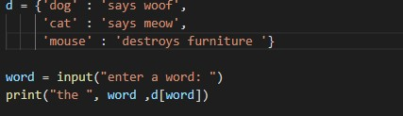
Note: The order of items in a dictionary will not necessarily be the order in which put them into the dictionary. Internally, Python rearranges things in a dictionary in order to optimize performance.

Accessing Items in a dictionary
You can access the items of a dictionary by referring to its key name, inside square brackets:

Example
Get the value of the "model" key:
x = thisdict["model"]
There is also a method called get() that will give you the same result:

Example
Get the value of the "model" key:
x = thisdict.get("model")

how to Change Values in a dictionary
You can change the value of a specific item by referring to its key name:

Example
Change the "year" to 2018:
thisdict = {
"brand": "Ford",
"model": "Mustang",
"year": 1964
}
thisdict["year"] = 2018

Loop Through a Dictionary
You can loop through a dictionary by using a for loop.
When looping through a dictionary, the return value are the keys of the dictionary, but there are methods to return the values as well.

Example
Print all key names in the dictionary, one by one:
for x in thisdict:
print(x)

Example
Print all values in the dictionary, one by one:
for x in thisdict:
print(thisdict[x])

Example
You can also use the values() function to return values of a dictionary:
for x in thisdict.values():
print(x)

Example
Loop through both keys and values, by using the items() function:
for x, y in thisdict.items():
print(x, y)

How to Check if a dictionary Key Exists
To determine if a specified key is present in a dictionary use the in keyword:

Example
Check if "model" is present in the dictionary:
thisdict = {
"brand": "Ford",
"model": "Mustang",
"year": 1964
}
if "model" in thisdict:
print("Yes, 'model' is one of the keys in the thisdict dictionary")

How to get the length of a Dictionary
To determine how many items (key-value pairs) a dictionary has, use the len() method.

Example
Print the number of items in the dictionary:
print(len(thisdict))

Adding Items to a dictionary
Adding an item to the dictionary is done by using a new index key and assigning a value to it:

Example
thisdict = {
"brand": "Ford",
"model": "Mustang",
"year": 1964
}
thisdict["color"] = "red"
print(thisdict)

Removing Items from a dictionary
There are several methods to remove items from a dictionary:

Example
The pop() method removes the item with the specified key name:
thisdict = {
"brand": "Ford",
"model": "Mustang",
"year": 1964
}
thisdict.pop("model")
print(thisdict)

Example
The popitem() method removes the last inserted item (in versions before 3.7, a random item is removed instead):
thisdict = {
"brand": "Ford",
"model": "Mustang",
"year": 1964
}
thisdict.popitem()
print(thisdict)

Example
The del keyword removes the item with the specified key name:
thisdict = {
"brand": "Ford",
"model": "Mustang",
"year": 1964
}
del thisdict["model"]
print(thisdict)

Example
The del keyword can also delete the dictionary completely:
thisdict = {
"brand": "Ford",
"model": "Mustang",
"year": 1964
}
del thisdict
print(thisdict) #this will cause an error because "thisdict" no longer exists.

Example
The clear() keyword empties the dictionary:
thisdict = {
"brand": "Ford",
"model": "Mustang",
"year": 1964
}
thisdict.clear()
print(thisdict)

Copy a Dictionary
You cannot copy a dictionary simply by typing dict2 = dict1, because: dict2 will only be a reference to dict1, and changes made in dict1 will automatically also be made in dict2.
There are ways to make a copy, one way is to use the built-in Dictionary method copy().

Example
Make a copy of a dictionary with the copy() method:
thisdict = {
"brand": "Ford",
"model": "Mustang",
"year": 1964
}
mydict = thisdict.copy()
print(mydict)
Another way to make a copy is to use the built-in method dict().

Example
Make a copy of a dictionary with the dict() method:
thisdict = {
"brand": "Ford",
"model": "Mustang",
"year": 1964
}
mydict = dict(thisdict)
print(mydict)

Nested Dictionaries
A dictionary can also contain many dictionaries, this is called nested dictionaries.

Example
Create a dictionary that contain three dictionaries:
myfamily = {
"child1" : {
"name" : "Emil",
"year" : 2004
},
"child2" : {
"name" : "Tobias",
"year" : 2007
},
"child3" : {
"name" : "Linus",
"year" : 2011
}
}
Or, if you want to nest three dictionaries that already exists as dictionaries:

Example
Create three dictionaries, than create one dictionary that will contain the other three dictionaries:
child1 = {
"name" : "Emil",
"year" : 2004
}
child2 = {
"name" : "Tobias",
"year" : 2007
}
child3 = {
"name" : "Linus",
"year" : 2011
}
myfamily = {
"child1" : child1,
"child2" : child2,
"child3" : child3

The dict() Constructor
It is also possible to use the dict() constructor to make a new dictionary:

Example
thisdict = dict(brand="Ford", model="Mustang", year=1964)
# note that keywords are not string literals
# note the use of equals rather than colon for the assignment
print(thisdict)

Dictionary Methods
Python has a set of built-in methods that you can use on dictionaries.
Method | Description
clear() | Removes all the elements from the dictionary
copy() | Returns a copy of the dictionary
fromkeys() | Returns a dictionary with the specified keys and values
get() | Returns the value of the specified key
items() | Returns a list containing a tuple for each key value pair
keys() | Returns a list containing the dictionary's keys
pop() | Removes the element with the specified key
popitem() | Removes the last inserted key-value pair
setdefault() | Returns the value of the specified key. If the key does not exist: insert the key, with the specified value
update() | Updates the dictionary with the specified key-value pairs
values() | Returns a list of all the values in the dictionary

